Prospectus
2024-2025
Realise Your Potential – Cyrraedd Eich Potensial

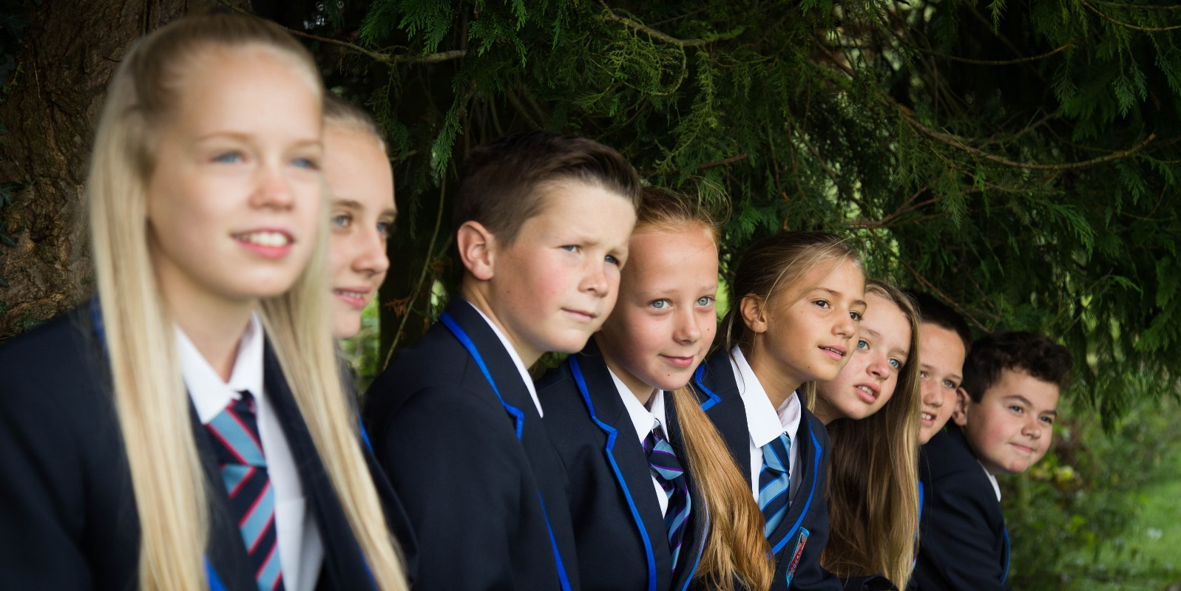

September 2023

Dear Parent/Guardian,

We at The Maelor School are proud of our achievements and hope your child will become part of the continuing success story. Our staff are highly committed and work hard to get the best out of our pupils both academically and through extra-curricular activities.

The Maelor School continues to have a strong reputation for Behaviour, Standards and Wellbeing. A recent GWE inspection of the school wrote, “Pupils have an excellent attitude to learning and have a high level of engagement, resilience and interest in their work.” They also wrote, “Behaviour both inside the classroom and in their free time is excellent and there is a positive and co-operative atmosphere in the school.”

As a school we set very high standards and expect our pupils to work hard, behave well and dress smartly. We encourage all our pupils to take part in a wide variety of activities and our aim is to produce pupils who have the skills and motivation to succeed in adult life. Our examination performance at both GCSE and A’ Level are the best in the area and we pride ourselves on supporting each child to achieve their potential.

The governing body have resolved to keep the school at its present size to preserve the relatively small-school character where pupils are known as individuals and the aspirations of our essentially rural community are best fulfilled.

We are small enough to respond to each child's individuality whilst encouraging all to play a full part in a caring community and large enough to offer a wide variety of courses. We are rural but not isolated, away from some of the pressures of urban life but in touch with all the latest educational ideas. Many parents who live outside our normal catchment area choose us as the school where their children will find challenges in a secure environment.

We are proud of the calm, purposeful working atmosphere which typifies every school day here and we are confident you too will be impressed.

We hope to hold our Open Evening on the 3rd October and Open Day on the 4th of October.

We are dedicated to providing you with the best information we can, please visit our Year 6 webpage to explore the opportunities for finding out about the school and how to apply.
https://www.maelorschool.org.uk/school-information/prospectus.php

I look forward to seeing you in the near future and welcoming your child next year.

Simon Ellis
Headteacher

THE CONTEXT

The Maelor School is a mixed comprehensive school for pupils between 11 and 18 years of age. It was established in the heart of the Maelor in the small village of Penley in 1957 to serve the needs of this extensive rural area. There are five forms of entry (approximately 130 pupils annually) giving a total of 810, including the sixth form of 160 students. Pupils are drawn from eight contributory primary schools in the Maelor, and a number of pupils join us from adjoining areas.

The school is located in extensive grounds in a very pleasant rural situation. The facilities available enable us to run the full range of activities expected of a forward-looking comprehensive school. These include our excellent specialist science laboratories and design technology workshops. There are five fully equipped computer suites in addition to a number of computers located in classrooms and specialist teaching areas for all subjects, a large gymnasium and a purpose-built new block of four specialist humanities classrooms.

At present there are fifty-five fully qualified teachers on the staff providing specialist tuition in all areas of the curriculum and the pupil-teacher ratio of one teacher for every sixteen pupils enables us to run a number of small classes.

FINDING OUT ABOUT THE SCHOOL

Open Evening, Tuesday, 3rd OCTOBER 2023 (5:30pm – 8:00pm)
Open Day, Wednesday 4th OCTOBER 2023 (9.30am-12.00pm, 1.40pm-3.00pm)

Please visit the dedicated Year 6 page for these events:-
https://www.maelorschool.org.uk/school-information/prospectus.php

ONCE THE CHOICE IS MADE

There are close links between the school and its contributory Primary Schools. Ms. Davies, the primary liaison teacher, visits all the schools on a number of occasions during the year. Year 6 pupils visit The Maelor School in June to spend a full day meeting their form tutor and taking part in sample lessons with their future class. Parents are also invited to meet the Headteacher, senior staff, and the form tutors during an evening meeting in June.

The Maelor School- Realise Your Potential

- To enable each pupil to fulfil her/his potential.
This concerns all aspects of a pupil's learning: intellectual, moral, social, aesthetic, practical, personal and physical.

- To enable each pupil to cope with life after school.
This concerns providing the knowledge, teaching the skills and developing the confidence and self-esteem which all pupils need to cope with the uncertainties of a rapidly changing society.

3. To enable each pupil to develop into a mature and responsible adult. This concerns the provision of learning experiences which develop pupils' resources for coping with difficulties, for taking responsibility for themselves and others and for working co-operatively and harmoniously together.

MORE SPECIFIC GOALS
1. To help pupils to develop lively, inquiring minds, the ability to question and argue rationally and to apply themselves to tasks, and physical skills.
2. To help pupils to acquire understanding, knowledge and skills relevant to adult life and employment in a fast-changing world.
3. To help pupils to develop literacy, numeracy and I.C.T. skills effectively.
4. To help pupils develop personal moral values, respect for religious values and tolerance of other races, religions and ways of life.
5. To help pupils to understand the world in which they live, and the inter-dependence of individuals, groups and nations.
6. To help pupils to appreciate human achievements and aspirations.
7. To provide each pupil with access to a broad and balanced curriculum and to a full range of extra- curricular experiences.
8. To encourage all pupils to take part in as wide a range of activities as possible, including residential experience.

2022-2023 Academic Performance

Attendance: 92%

Key Stage 3 School Wales

Pupils achieving level 5+ in English 92% 85%
Mathematics 95% 86%
Science 98% 87%

Pupils achieving level 6+ in English 77% 54%
Mathematics 82% 58%
Science 81% 58%

Pupils achieving level 5+ in English, Maths & Science 89% 78%

Key Stage 4

Pupils achieving 5 GCSE grades A* -A 31% 18%
Capped Points Score 416 354
5 GCSE A*-C 94%

Key Stage 5

Grades awarded A*/A 40%
Grades awarded A*/C 86%
Pupils achieving 2 A levels (Level 3 threshold) 100%

SCHOOL HOURS

School starts at 8.55 a.m. and finishes at 3.30 p.m.

There are five one-hour sessions each day, giving a total of 25 hours teaching time per week.

Morning Afternoon
Registration 08.55 a.m. Registration 1.25 - 1.30 p.m.
Session 1 09.15 - 10.15 a.m. Session 4 1.30 - 2.30 p.m.
Break 10.15 - 10.30 a.m. Session 5 2.30 - 3.30 p.m.
Session 2 10.30 - 11.30 a.m.
Session 3 11.30 - 12.30 p.m.
Lunch 12.30 - 1.25 p.m.

Attendance
Excellent attendance at school is an important factor in the overall achievement of pupils. Holidays during term time will only be authorised for exceptional circumstances. The Local Authority has the power to issue fixed penalty notices of £60 for unauthorised absence from school. These notices may be issued to address any unauthorised absence from school in excess of five school days in one term.
CURRICULUM ORGANISATION - THE LOWER SCHOOL

On arrival at the school each pupil is allocated to a tutor group under the specific care of a form tutor. During the first year (Year 7) pupils are taught initially in their tutor groups with some grouping by ability in Mathematics and Science. In Year 8 and upwards pupils are placed in ability bands in most subjects.

The Maelor School community wholeheartedly embodies the four purposes of the Curriculum for Wales which will enable our children to become:

· ambitious, capable learners,

· enterprising, creative contributors,

· healthy, confident individuals and

· ethical, informed citizens.

The goal of The Maelor School is to enable all our young people to ‘realise their potential’ within our happy, supportive and inspiring community.

We have high expectations for all our learners and value their diversity and the strengths of each unique person, taking pride in our culture. We encourage teamwork and collaboration and embrace every opportunity to develop self-respect, confidence and resilience, equipping our pupils to lead successful and fulfilling lives as individuals, professionals and global citizens.

The curriculum we provide is accessible, inclusive and challenging, offering rich learning experiences. It also offers opportunities for innovation, creativity and critical thinking in order to encourage development of independence, perseverance and personal effectiveness. We strive to enhance the use of digital technology to enable our pupils to become well-informed, responsible digital citizens and lifelong learners.

During Years 7 to 9 pupils follow a broad and balanced curriculum which incorporates all six Areas of Learning and Experience:

1. Languages, literacy and communication (English, Welsh and French)

2. Mathematics and numeracy (maths)

3. Science and technology (science, digital learning and design technology)

4. Humanities (history, geography, religion, values and ethics)

5. Expressive arts (art, music, media and performing arts)

6. Health and wellbeing (physical education, personal, social & health education and food & nutrition).

The curriculum is designed so that our pupils progress in both breadth and depth of their skills, knowledge and understanding, and can make links and connections between subjects to accelerate their learning so that they can solve problems and think creatively.

Pupils with specific learning difficulties are provided with specialist help either through support within their teaching group, backed up by individual tuition, or in small groups in the designated Learning Support Centre.

CURRICULUM ORGANISATION - THE UPPER SCHOOL

Pupils are able to choose some of their subjects and the curriculum for years 10 and 11 has been set up to safeguard breadth and balance in each student's programme. All students take Mathematics including Numeracy, English Language and Literature, Science and Welsh. As well as the subjects they have studied at KS3, pupils are able to take up a new subject if they wish such as Computing, Engineering, and Business Studies.

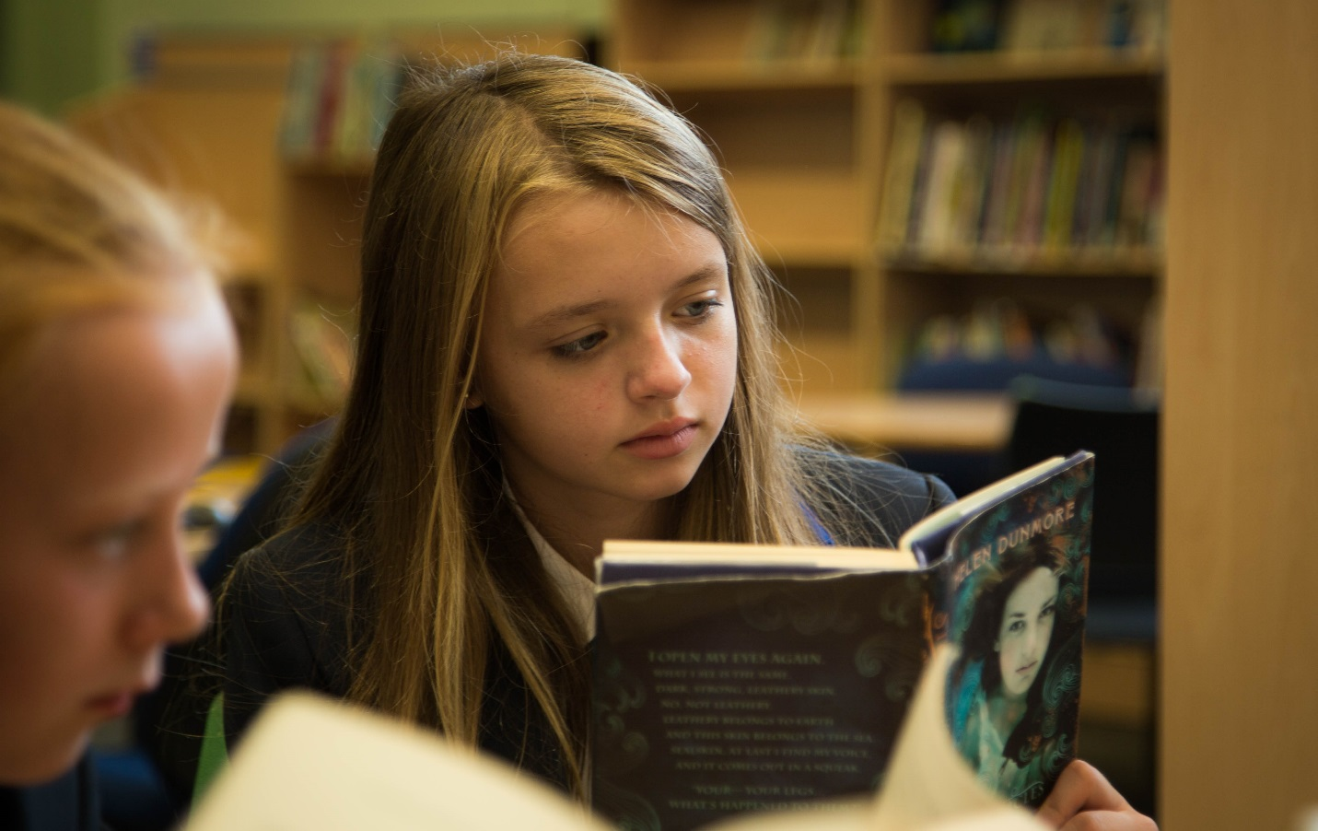

OPPORTUNITIES FOR ALL

At The Maelor School we do not operate a ‘one size fits all policy’! Those who have special talents in Science, Languages, the Humanities, Mathematics, Expressive Arts or Sport have opportunities to develop their talents by taking more subjects in their favoured area, by studying at greater depth or participating in extra-curricular activities which will challenge them to the full. We create these opportunities without imposing the enriched diet on everyone. Academic scientists will study Biology, Chemistry and Physics as separate G.C.S.E. subjects while their peers concentrate on dual award Science. Those interested in sport can take G.C.S.E. and ‘A’ level P.E., whilst developing their coaching skills in junior classes or with our primary colleagues. Our excellent links with local sports clubs provide coaching for regional and national representation. Those who are less talented will be encouraged to develop their personal fitness in their P.E. and Games lessons or take part in the 5 x 60 programme.

Extra-Curricular Activities.

- Well-received concerts have been held at School and in the community. Music tuition has been arranged for singing, woodwind, brass, strings, percussion, guitar and keyboards.

- A full programme of fixtures in team games has been completed with considerable success achieved by The Maelor School teams.
- Over 80 Year 8 pupils explored the culture of Northern France and visited Paris on the French trip.
- Twilight classes organised for drama and gymnastics are held on a weekly basis.

RELIGIOUS EDUCATION

A collective act of worship is held on a regular basis and R.E. is taught to all pupils. Parents, who for reasons of conscience, wish to withdraw their children from Assembly or R.E. lessons, must write to the Headteacher.

PERSONAL AND SOCIAL EDUCATION

Personal and Social Education is provided for all pupils during our P.G. days. Sex Education is dealt with in accordance with Government guidelines as approved by the Governing Body. Details of the courses and samples of materials used may be inspected by parents at the school. The most convenient time to discuss the materials will be during the Open Evening, held in October, when parents are welcomed at the school.

MUSIC

As well as the usual general education in Music, peripatetic teachers visit the school each week to teach Brass, Woodwind, Strings, Percussion, Guitar, Piano and Singing. The school has a flourishing String Orchestra, wind band and big band which have played at a number of concerts. Pupils are encouraged to join the school choir and to make a musical contribution to our school productions. Most of our musicians’ progress through the grades of the various music examining boards. Maelor School pupils make a large contribution to the area wind band and a number have progressed to the Area Youth Orchestra.

WELSH

This English-speaking school follows the policy on Welsh language teaching as laid down in the National Curriculum. This means that all pupils study Welsh in Years7-11 and achieve a GCSE in the subject. Welsh is available to study at A level.

.

CAREERS

Mr Graham Reardon (Head of Careers) coordinates the programme in school and organises a range of careers educational experiences for pupils. Evening meetings are held each year to explain the Government Training Schemes, Sixth Form Courses and relevant courses at F. E. Institutions and Agricultural Colleges. Effective use is made of the tutorial programme to provide structured careers advice during the senior school years which includes a computer package used by all pupils.

Students have free access to the careers library with its own computer facilities which is located adjacent to the library. Visiting speakers provide the employers' perspective as part of the P.S.E. programme and a number of trips are organised to careers fairs and work-based training activities. Mock interviews with employers from the local community are an important part of the programme.

ASSESSMENT

Pupils' progress is monitored in a variety of ways ranging from marking of classwork and homework to annual formal examinations. Continuous assessment is used to give an indication of progress throughout the year. However, formal tests provide an important measure of learning and are set when appropriate by individual Heads of Faculty.

We compile a profile of each child's potential following the ‘CATs’ testing that we arrange in September of Year 7. Performance in all subjects is assessed against this benchmark data on a termly basis to provide a clearer picture of achievement levels. Underachieving pupils can be identified, and mentoring initiated with the support of parents.

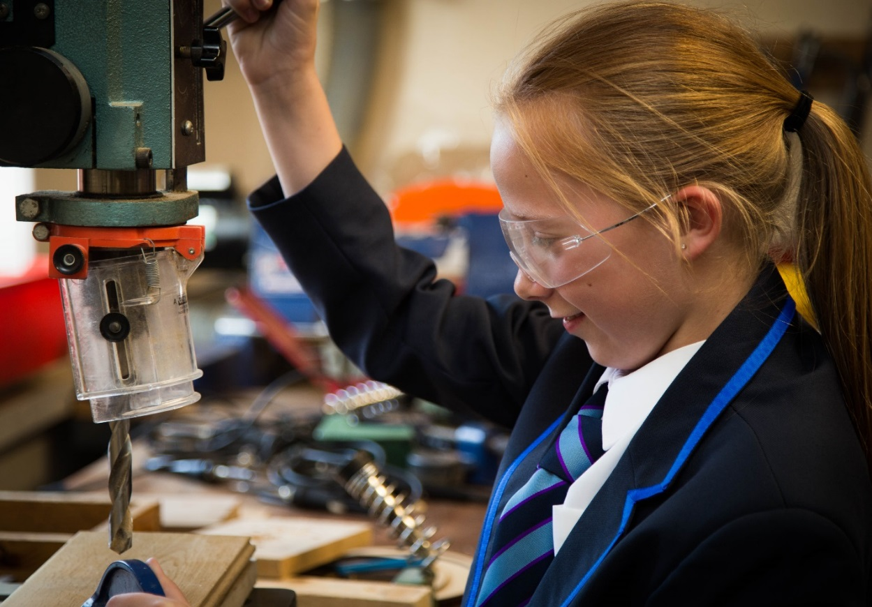

REPORTS

Parents receive three termly progress reports and one detailed report each year. There is an opportunity to discuss each pupil's progress with subject teachers during a Parents' Evening which is organised at a different time in the year for years 7, 8, 9,10 and 11. Parents can be provided with a progress report at any time between these arrangements and we welcome the opportunity to discuss concerns as they arise. Contact will be made with home if termly assessments indicate clear underachievement.

HOMEWORK

Homework is an important and necessary part of the work of the school. It provides an opportunity for consolidating work introduced in the day, to follow-up work in depth and to make use of learning opportunities outside the classroom. The setting of homework is the responsibility of the subject teacher. Year 7 pupils will be expected to do between one and one and a half hour's homework each night. Each pupil is provided with a student planner to record each evening's set tasks. We find this helps our pupils to plan their work and keeps parents informed. The planner can also be used to encourage dialogue between parents and teachers.

REWARDS

Our reward system seeks to acknowledge the consistent good behaviour and work of pupils in addition to rewarding outstanding performance or especially praiseworthy contributions to the life of the school.

Achievement Points are used to reward individual excellence, particular helpfulness or a marked improvement in performance. Regular periodic reviews of classroom behaviour and standards of work are also used to award Achievement Points on a card for each pupil. When a number of Achievement Points are completed, pupils are awarded a bronze certificate, with silver and gold awards to follow for those who continue to do well. The form tutor, as coordinator of the scheme, keeps in regular contact with how well each pupil is doing. Pupils deserving special credit are seen by the Headteacher.

A Celebration Evening is held in the summer term to recognise the effort and achievement of pupils nominated for special praise by their teachers.

We think it is important to communicate good news to parents on a regular basis as well as sharing concerns as they arise. Teachers send cards home to notify parents of good performance and attendance and commendation certificates are awarded on a termly basis.

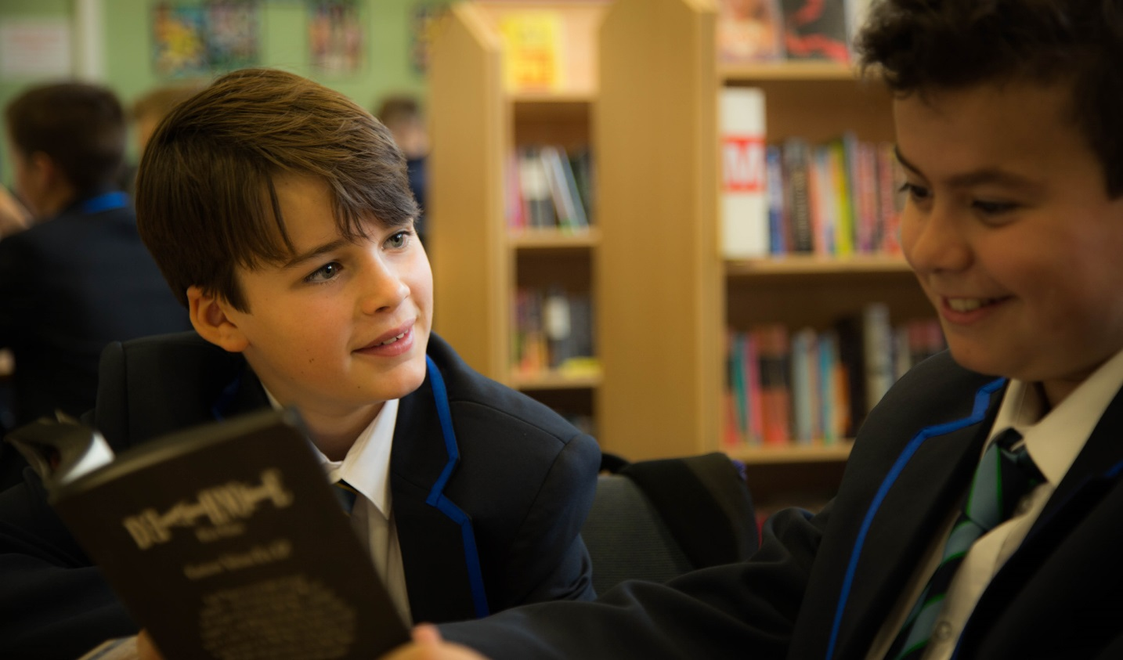

CONSEQUENCES
In addition to the usual sanctions, (e.g. reprimands, subject detentions) pupils may be kept in at lunchtimes. In more serious cases pupils may be detained after school for an hour or more after parents have been informed in advance by letter. Pupils may be suspended from school if all other sanctions fail.

THE PASTORAL STAFF
The Head of Year/Pastoral Managers are responsible for the overall care, discipline and progress of all pupils in the year. The form tutor deals with everyday problems and registers the pupils twice each day. S/he is the person who will get to know your child best.

PASTORAL CARE
The quality of the relationships between staff and pupils at The Maelor School is an important element in creating an orderly, caring community in which purposeful learning can take place.

Pastoral care is the responsibility of all staff. However, the form tutor is the key to effective pastoral care because of the daily contact s/he has with a small number of pupils. Worries, anxieties or any matter of concern can therefore be picked up at an early stage. The tutor will also provide a lead in developing personal and social skills through the tutorial programme.

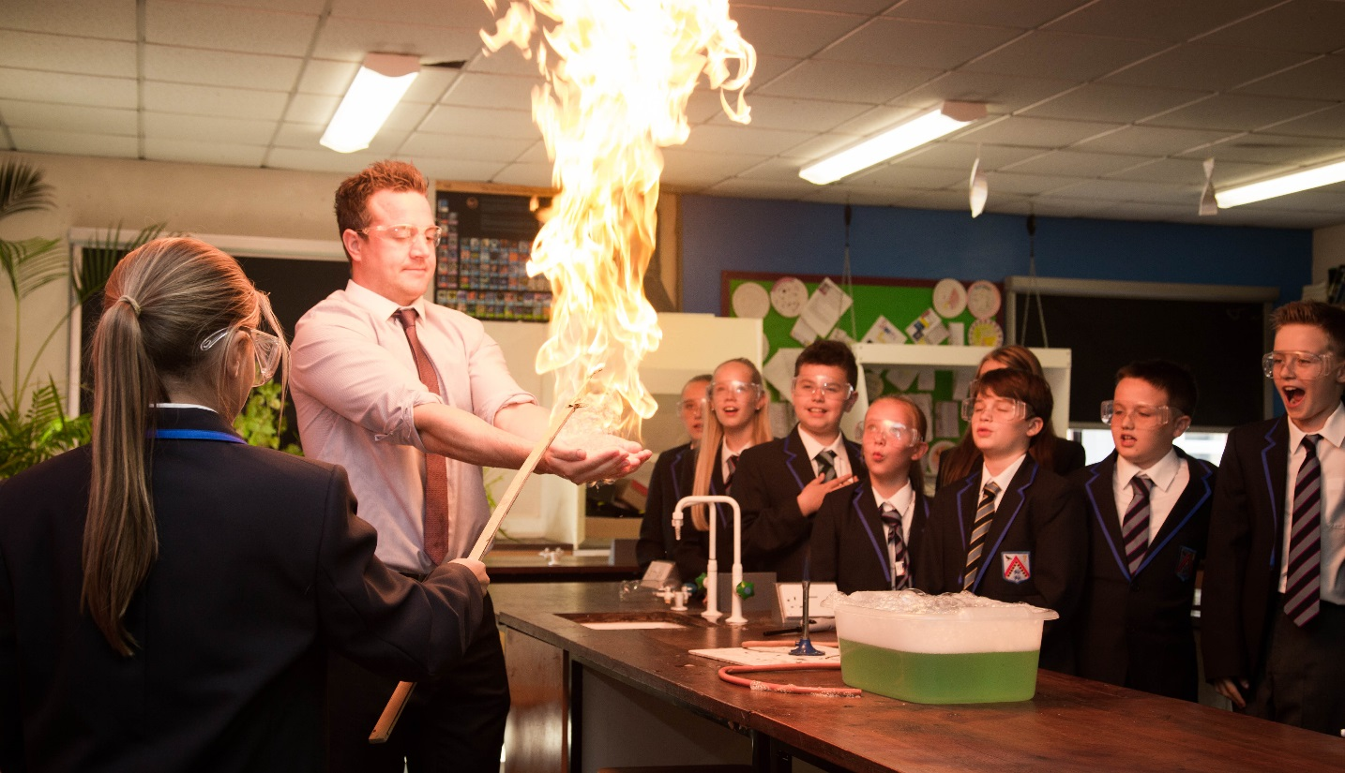
Pupil self-assessment is an important part of lessons and the tutorial programme throughout the school. This provides an invaluable stimulus for pupils to manage themselves and their learning more effectively using individual action plans and personal learning programmes.

MAELOR SIXTH

Our choice of 'A' level subjects is comprehensive and includes:-

Art, Biology, Business Studies, Chemistry, Design & Technology, Economics, English Literature, French, Geography, Politics, History, ICT, Mathematics, Further Mathematics, Music, Physical Education, Physics, Psychology, Religious Studies, Environment Studies, Medical Science, Criminology and Welsh.

Some of the above subjects are delivered as part of the 16 – 19 collaborative arrangements and every effort is made to meet individual requirements.

With such excellent ‘A’ level results sustained over recent years, placing us in the top comprehensive schools in the U.K., we have attracted pupils from a number of other schools in the area including those from public schools. A separate sixth form prospectus is available on request.

All our Year 12 students will be taking part in the Welsh Baccalaureate. On successful completion the qualification is worth the equivalent of an ‘A’ level.

MAELOR SIXTH

We also offer a range of additional curriculum opportunities which include:-
- Mentoring younger pupils in literacy and numeracy
- Coaching in our sports teams
- Oxford and Cambridge pathways programmes
- Election to the school council and attendance at governing body meetings
- Engagement in management and engineering training schemes
- Supporting local and national charities with a range of fundraising activities
- Engagement in Rotary leadership team building programmes
- Study in Georgia, USA as part of the Rotary Club student scholarship programme
- Participation in the US Sutton Trust programme

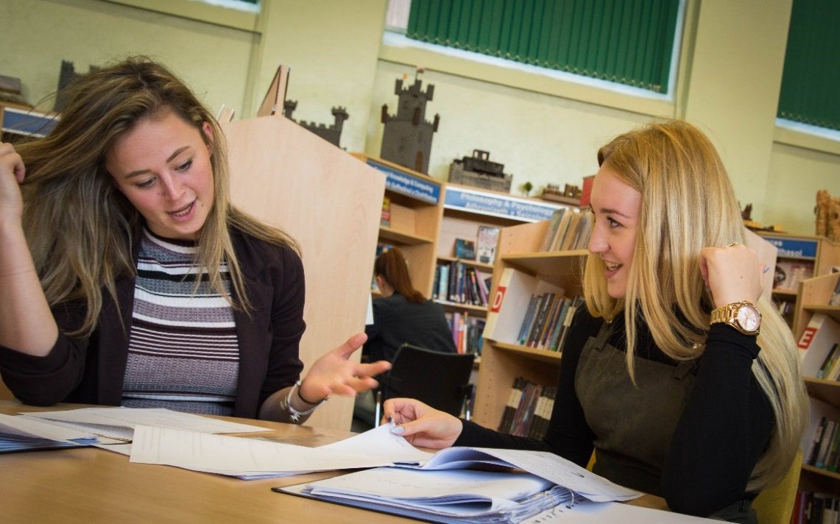

POSITIVE ASSERTIVE DISCIPLINE POLICY

Our Positive Assertive Discipline Policy defines our clear expectations of pupils’ behaviour, the rewards for following the code and the consequences of failing to comply. The four consequences are applied in sequence beginning with a verbal warning and progressing through interim measures to a note home and finally exclusion from the classroom.
In this way we hope to minimise lesson disruption and create an even more positive classroom atmosphere. We wish to underline our support for the rights of the majority to maximise their learning opportunities.

SCHOOL MEALS

A wide range of foods can be purchased in the cafeteria. Breakfast and drinks are also available during morning break [10:15 – 10:30am].

Free school meals – If you feel your child is entitled to free school meals, please contact the Wrexham Local Education Department or complete their on-line application claim form:
https://www.wrexham.gov.uk/service/school-meals/free-school-meals

THE LEARNING RESOURCE CENTRE

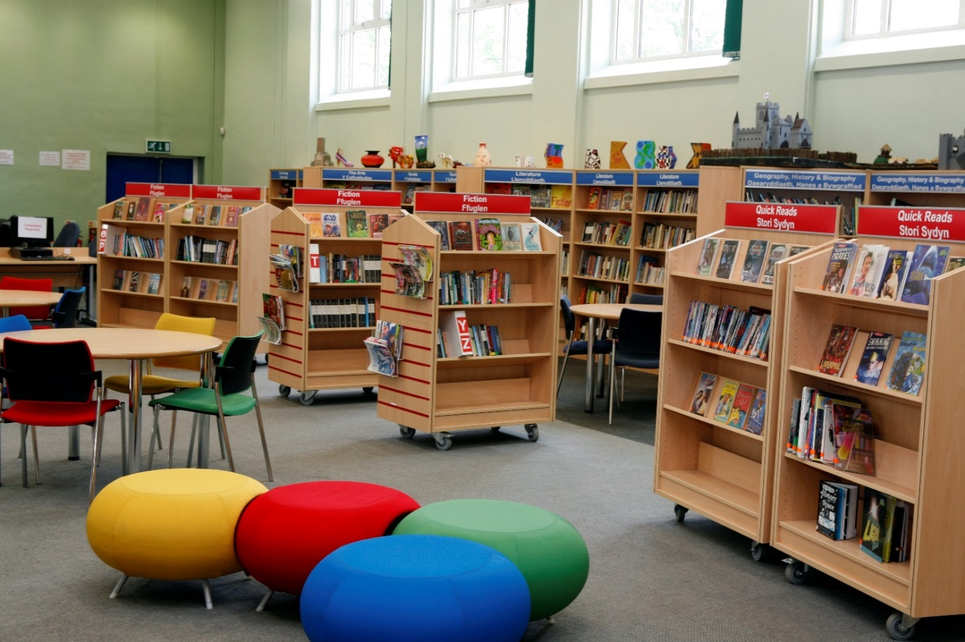
The LRC is central to much of the work conducted in the school, whether from the point of view of borrowing books of general interest - fiction or non-fiction - or as an aid to the preparation of work through the use of appropriate reference books. It is open to pupils every lunchtime and pupils have access to the LRC for reference work during lesson-time when the Librarian is on hand to offer advice. A substantial grant from the Dame Dorothy Jeffries Trust plus generous support from the P.T.A. have enabled us to modernise and expand the stock over the past few years.

ADMISSIONS POLICY

The school complies with the Education Act 2009 which gives priority to the admission of Looked After Children.
In the event of admissions applications exceeding our standard number of 130, the governors have agreed that the following criteria should be applied in the order of priority shown:-
Oversubscription Criteria:
- “Looked After Children” and “previously looked after children”
- Attendance at the feeder primary schools in the Maelor: Ysgol Sant Dunawd - Bangor on Dee, Bronington Aided Primary - Bronington, Eyton V. Controlled Primary - Eyton, St Chad’s V.Aided Primary School - Hanmer, St Paul’s V. Aided Primary - Isycoed, Madras Church in Wales Aided Primary - Penley, Ysgol Deiniol C. P. - Marchwiel, St. Mary’s Aided – Overton on Dee and Borderbrook V.C. Primary -Tallarn Green.
- Siblings of pupils already attending the 11-16 part of the school. [Brothers and sisters whether full, half, step or foster will be considered relevant where living together in the same family household and address and where the older child will still be registered at the school when the younger child would be eligible to attend. Children residing in the same household as part of an ‘extended family’ such as cousins, will not be treated as siblings. Siblings will be in years 8-11 when the younger child is due to start.]
- Proximity – Priority is given on the shortest distance [Distances are measured by the shortest available walking route from home to school, which may include public footpaths. The shortest available route is one along which it is considered safe for a child without a disability or learning difficulty to walk the route, or with an escort if the age of the child would call for such in accordance with the Welsh Government – ‘Learner Travel Statutory provision and Operational Guidance’.]

In the event of being oversubscribed in criteria 2 and 3, the distance as set out in criteria 4 will be used as a tie break.

Declined a Place: If you are refused a place after the school has applied the above admissions criteria you have a right to appeal to an independent appeals panel. In order to do this a Parent/Carer should request an appeal in writing to the “Clerk to the Appeals Panel” at the school’s address.

Multiple Births Admission Criteria: When the Governing Body are considering twins, triplets or other multiple births for one remaining place, the family will be offered the place and may decide (a) if they accept it for one sibling whomever they decide or (b) they decline the place and it is offered to the next person in the allocation after the twin/triplets/multiple births. Please note the multiple birth sibling(s) would not be given priority on admission other than considered as a sibling link once the family had accepted the place(s) offered for one of the twins/triplets/multiple births.

Waiting List:
The Maelor School will maintain a waiting list following the allocation of places during the normal admissions round. The waiting list will remain in place until the 30^{th of} September in the school year in which the application is made. For mid school transfer applications, the Maelor School will keep the application on the waiting list for the academic year in which the application is made.

Thereafter parents should make a fresh application for admission. If additional places become available while the waiting list is in operation, they will be allocated to children on the waiting list based on the oversubscription criteria and not on the date of the application. If places become available prior to the appeals hearing they will be filled from the waiting list.

Late Applications:
Applications received after the published closing date will be treated as a late application. Late applications will be considered using the same published criteria. However, if the school is over-subscribed then any late applications will be looked at after those applications received by the closing date.

Applications outside the normal admission round:
The school will apply the admission policy to all applications received outside the normal admissions round or for other year groups (mid school transfers) using the criteria and arrangements set out above.

HOW TO APPLY FOR A PLACE
You will need to complete a Wrexham Admission Pack available to download from the Wrexham Authority website www.wrexham.gov.uk and follow the links to Education & Learning, Schools Admissions & Transfers. The application form should be returned to the LA by the published annual date. (If your child attends a Wrexham primary school this information will be given to them at the beginning of the Autumn term.) It is simpler if the application can be made using the Local Authority Online application form.
You will also need to complete The Maelor School admission form or via our school website by 6th November 2023. You will also need to complete the Wrexham LA On-line Application Form, please see their website for details.
The Maelor School allocation period is 6th November until 8th January 2024
Please ensure you return both application forms. If successful you will be informed of your place at The Maelor School by the 1st March 2024.
TRANSPORT

Free Transport
Attendance at a named feeder primary school does not automatically entitle a pupil to free transport to The Maelor School.

Wrexham County Borough will provide assisted home to school transport under the following circumstances:
- where a child resides over three miles from their nearest appropriate secondary school.
- where the route to school is considered to be hazardous by the County Borough Council.
- where a child requires transport on medical grounds and no suitable public transport exists.
- where transport to an identified school is essential in a pupil’s statement of Special Educational Needs. This would normally be on medical, social or educational grounds, and would be deemed essential in the context of other criteria identified in this policy.
An appropriate school is deemed to be the nearest school that provides education for the relevant age and ability of a pupil.
Please contact the Wrexham County Borough School Transport Department on (01978) 292056 for an application form if eligible for free transport.

Paid Transport
For those pupils who wish to attend The Maelor School but do not qualify for free transport, the school provides a number of routes to the school. If you would like further information regarding school transport routes and cost, please contact our Transport Co-ordinator.

Mr. Andy Heron (Transport Co-Ordinator) 01948 832010. transport@maelorschool.org.uk

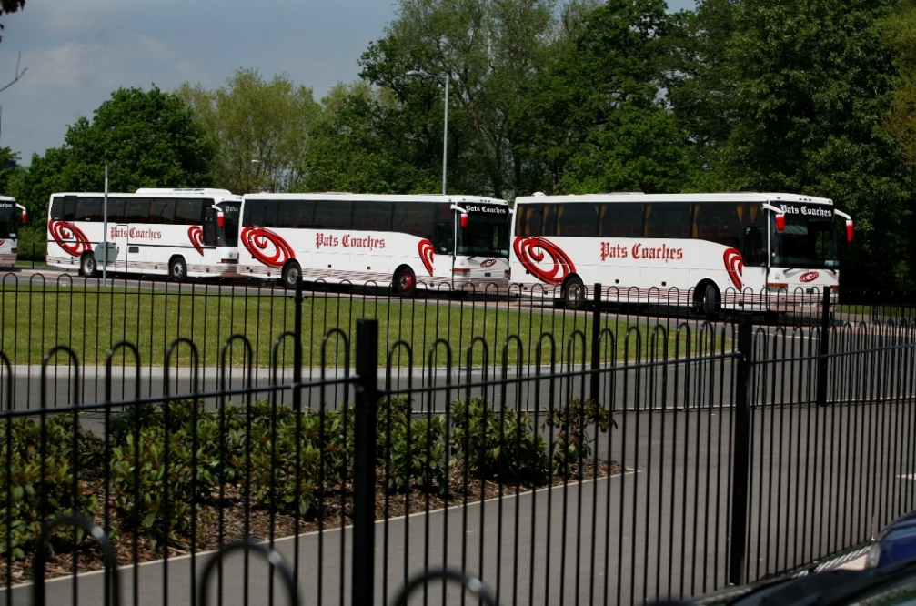

ADDENDUM NOTE TO THE MAELOR SCHOOL PROSPECTUS 2024/2025

The Governors wish to advise that although the information or particulars contained herein were correct on 1st September 2023 it should not be assumed that there will be no change affecting the relevant arrangements or some matter particularised -

a) before start of, or during the school year in question; or

b) in relation to subsequent school years.

Headteacher: Mr Simon Ellis
Email: contact@maelorschool.org.uk

The Maelor School
Foundation School
Penley
Wrexham LL13 0LU
Tel: 01948 830291

www.maelorschool.org.uk
@maelorpenley

